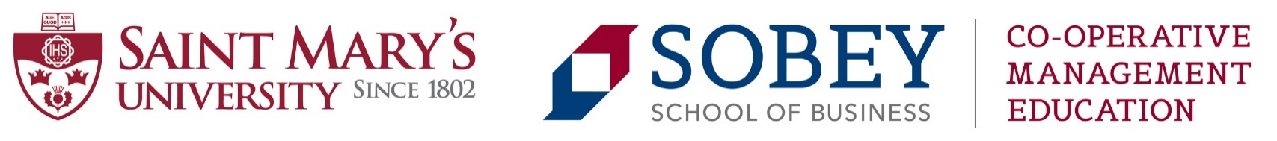

Enhancing Business Performance through Co-operative Management Practices:
How to Strengthen Identity, Loyalty and Participation

An interactive, 3-day intensive professional development opportunity focused on leading thinking in co-operative management coupled with tangible examples of how to translate knowledge into action. We encourage senior managers, CEOs and board members to join us for this learning and networking event.

- How to approach the management of a co-operative/credit union/mutual
- Establishing a competitive advantage using the co-operative model
- Co-operative economic trends and the local-to-global context

Lead Instructor: Daniel Côté. Executives in Residence and other experts vary depending on location.

Cost: $1,500 CAD (Includes course fee, lunches, snacks, 1 supper). Some course subsidies are available.

Options: November 1-3, 2017 (Vancouver, Canada) - hosted by Vancity Credit Union
Dates and locations for 2018 TBC (check website for details). Contact us if you would like to host!

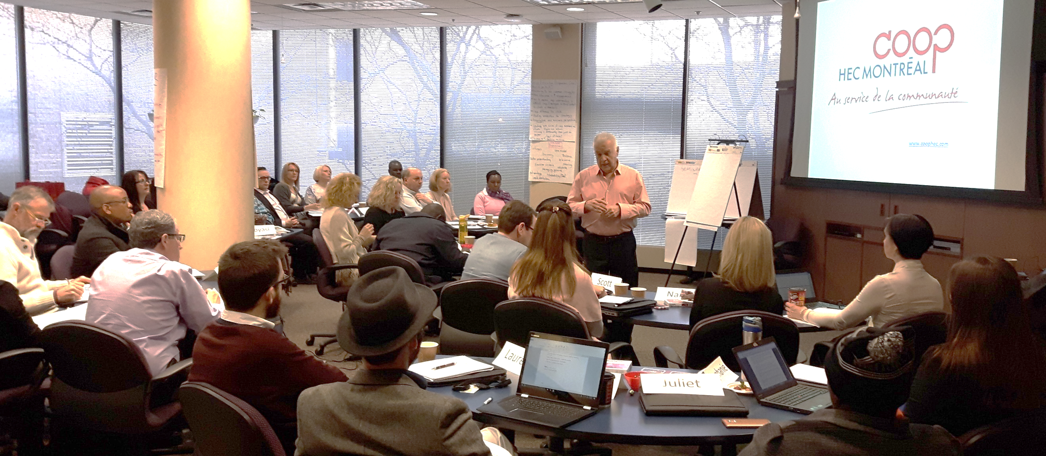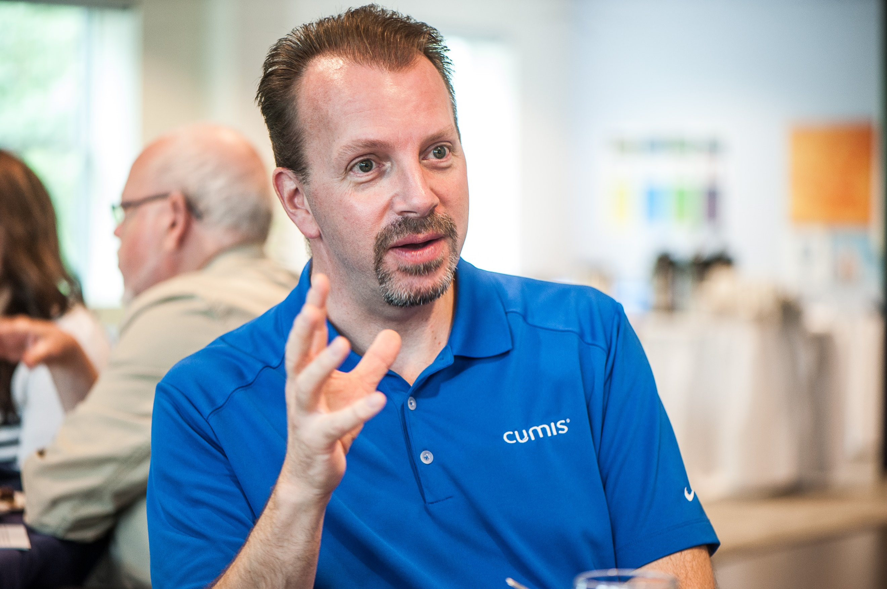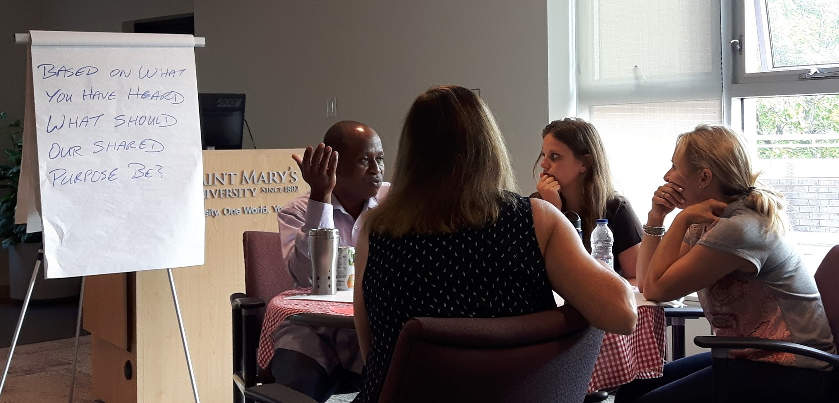

What to expect:
First, we will get into gear by setting the context including an exploration of how current day co-operative enterprises fit within a wider economy.

Learn how to manage the co-operative equilibrium. The focus is placed on a model that captures the uniqueness of co-operative organizations, building on the dual nature of a member’s usership and ownership. We will address issues of core values and their purpose, the co-operative business model, and balanced scorecard to lead into discussion of a co-operative equilibrium. Emphasis is placed on the alignment from co-op values to key performance indicators. Cases of cooperatives successfully managing partially or totally this equilibrium will be discussed.

Move from a potential identity crisis to the New Co-operative Paradigm (NCP). The traditional co-operative model is being challenged leading to an identity crisis. A model to better understand this reality will be introduced, taking into consideration both co-operative rules and market rules. In response to this state of crisis, a NCP is being proposed, showing how the emerging market rules can be of great advantage to co-operatives. Examine case studies and deep dive into implementation success stories such as the customer orientation strategy.

Gain exposure to emerging concepts in the field of management and governance in the context of co-operative enterprises. This course will provide you with tools to better understand the existing culture in your co-operative and equip you with techniques that promote engaged participation by members.

What participants have said:

“The CME Executive Education program is the best introduction to the values-based co-operative business model. Using real world case studies that illustrate what works and lessons learned where things didn’t work, those who attend gain so much they can bring back to their own co-op businesses. Co-operative leaders and those who are interested in the model can see how co-operative management approaches can lead to successful alternative models to traditional business structures that offer great benefits to the community. I especially like the new relationships formed which have resulted in much more sharing of ideas since the program. I would highly recommend this program to build one’s knowledge in this emerging and important sector.”
John Allen, Vice President, People Solutions, Vancity

“My credit union’s CEO was a full year into the Saint Mary’s Master of Management, Co-operatives and Credit Unions program when I noticed he was bringing a whole new way of thinking to the Board of Directors. I needed to gain a greater knowledge and understanding of co-operative business. When I found the executive education program, I immediately registered. It was well worth the time, effort, and investment in a credit union director’s professional development. The program had co-operators from a wide cross-section of co-operatives and credit unions, and a wide geographic representation diversity as well. The networking among the group was absolutely worth the investment. This is a superb professional development opportunity, and I would recommend it. I assure you it will generate a new spirit of co-operation that will enhance your value differentiator in our business environment.”
Gary J O’Brien, Chair of Leading Edge Credit Union, Director on the board of Atlantic Central, Director on the board of League Saving & Mortgage Co., and Corporate Secretary to the Board of Directors for the Newfoundland & Labrador Federation of Co-operatives

“The 3-day Executive Education program gave me an invaluable insight into what truly makes a co-op different. I came away with examples from other co-ops that really made me think about the role leaders play in bringing co-op values and purpose to life. It was also great to feel part of a wider co-op community and share insights and experiences about some of the common dilemmas we face.”
Nicola Rowe, Senior Leadership Development Manager, The Co-operative Group (UK)

“I could not more highly recommend the Executive Education program offered by Saint Mary’s University. It was a highly valuable experience for me on an individual level, and continues to have worth vis-à-vis my professional and institutional work with the International Co-operative Alliance. Co-op Management Education at Saint Mary’s curated a very rich selection of case studies and preparatory course material that we then delved more deeply into with co-operative practitioners from around the world and across all sectors of the economy. It was, especially, their insights and perspectives that made this a particularly enriching professional educational experience. I would sign up again and encourage co-operators in all industries to invest in this experience.”
Hanan El-Youssef, Director of Strategy, International Co-operative Alliance
Beyond 3-Day Executive Education courses, we also offer:

- Master of Management, Co-operatives and Credit Unions (part-time, online, 3 years)
- Graduate Diploma in Co-operative Management (part-time, online, 20 months)
- Certificate in Co-operative Management (part-time, online, 10 months)
- Co-operative Study Tours (Spain & Italy), International Symposium on Co-op Accounting and Reporting

Register via Erin Hancock at cme@smu.ca or by visiting s.coop/exceed

MANAGEMENTSTUDIES.COOP

